TASK 5: CAPTURE AND ANALYZE NETWORK TRAFFIC USING WIRESHARK.

- Install Wireshark

We can install Wireshark using the official website (for windows),
Wireshark • Go Deep | Download
Or we can also download it Linux terminal using the command (for Linux machines),
``` sudo apt install wireshark –y ```

- Start capturing on your active network interface.

I tested a simple jquery site which as no encryption and no http in it, which means the data that transfer from browser to server can be seen by anyone listening on this page can view username and password.

- The website Login Test
- Stop capturing the packets using STOP CAPTURING PACKETS button which is in red colour in top right.

- After logging, below are the captures packets:
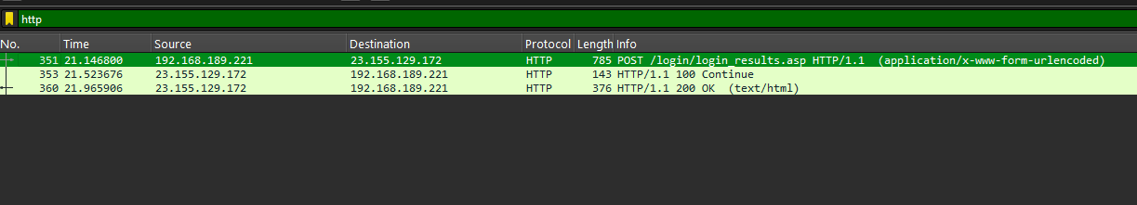

Username and password can be seen:
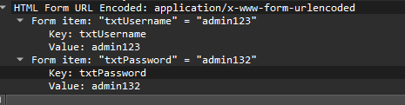

- Search for different protocols like http, http1, http, http3, dns, tcp, ip.addr in the search bar.
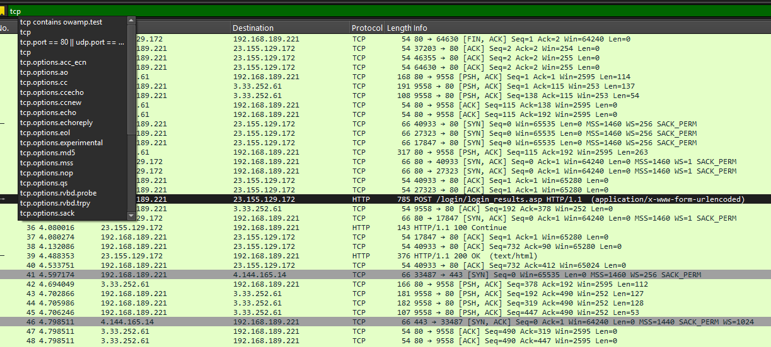
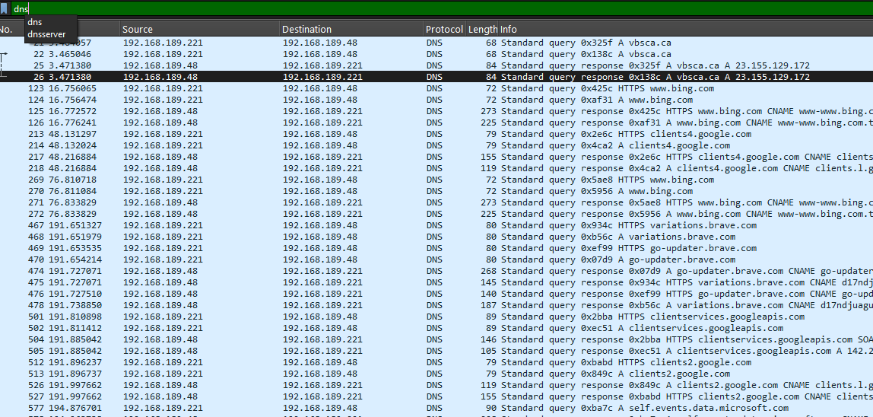

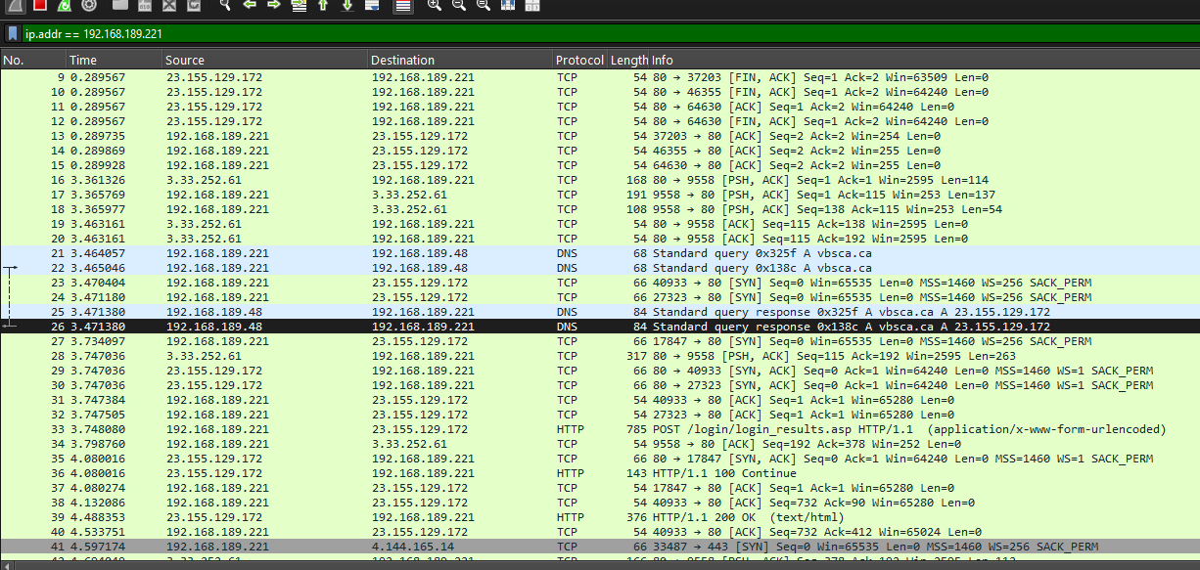

- Export the capture as a .pcap file.

Go to file menu:
Click on Export Specified Packets / click Save As…
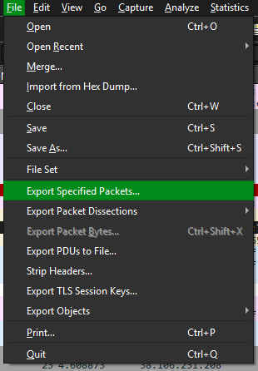

Enter the file name and export the file in Wireshark/tcpdump/…- pcap extension.
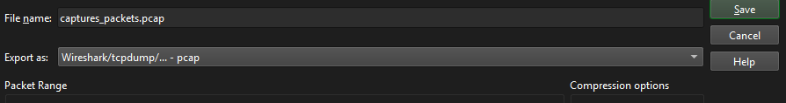
Click on save.

